**Strategy Overview**

The Sector Rotation investment program is a tactical long term growth strategy designed for capital appreciation. The strategy seeks sectors that are expected to outperform the S&P 500 Index in a favorable market environment while investing is short term treasuries and sectors that are less correlated to S&P 500 in a volatile market. The investment process is a three pronged approach, determines the Market Outlook, selects the best risk adjusted return ETF’s, and applies proprietary portfolio construction and risk management methodology.

**Investment Process**

**Primary Objective**

Long Term Capital Appreciation in favorable market environment and Capital Preservation in volatile markets.

**Annualized Returns (% Net)**

|  |  |  |  |  |  |  |
| --- | --- | --- | --- | --- | --- | --- |
| **% Returns** | **1 Year** | **3 Year** | **5 Year** | **10 Year** | **YTD** | **Since Inception** |
| **Strategy** | **16.63** | **12.57** | **13.13** | **14.66** | **5.85** | **10.50** |
| **S&P 500** | **16.14** | **12.39** | **12.98** | **10.56** | **6.49** | **7.00** |

**Risk Metrics (since 12/31/2002 vs S&P 500)**

**Annualized Returns (% Net)**

|  |  |  |  |  |  |  |
| --- | --- | --- | --- | --- | --- | --- |
|  | **Annualized Risk since Inception** | **Beta** | **Annualized Alpha** | **Sharpe Ratio** | **R-Square** | **Max Drawdown (%)** |
| **Strategy** | **11.79%** | **0.56** | **6.43** | **0.86** | **0.43** | **22.6** |
| **S&P 500** | **13.97%** | **1.00** | **-** | **0.48** | **-** | **46.3** |

**Risk Exposure vs S&P 500 – Blue bars indicates portfolio in risk averse state**

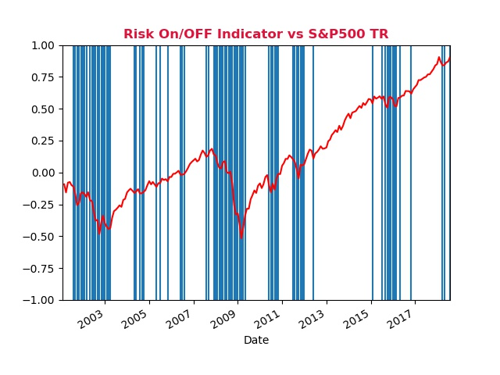

**Equity Curve (since 12/31/2001)**

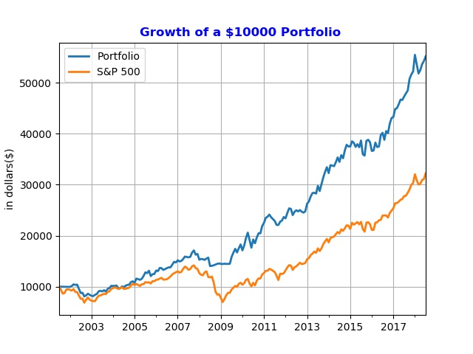

**Monthly Correlation vs S&P 500**

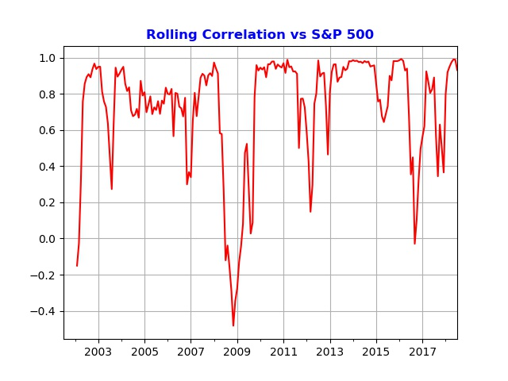

**Historical Performance as of 07/31/2018**

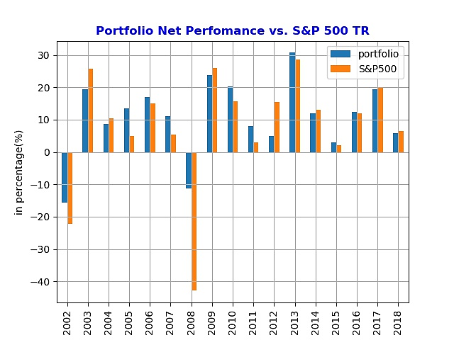

**Portfolio Holdings as of 7/31/2018**

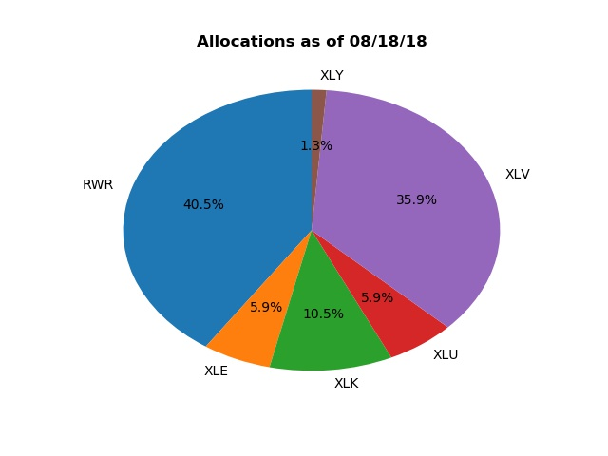

**Drawdown – Portfolio vs S&P 500**

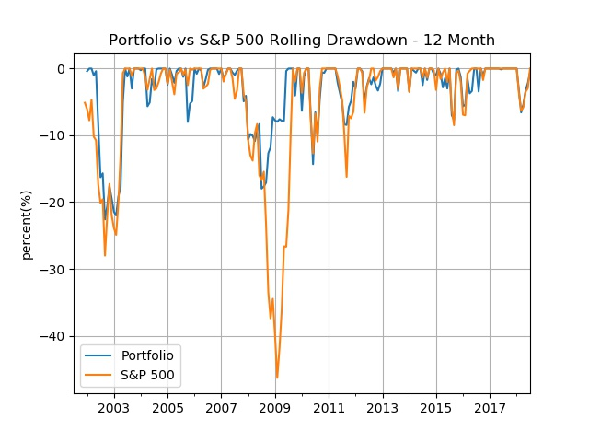

**Important Disclosure Information**

Past Performance is not indicative of future results. All investments involves risk, including loss of principal

Returns are presented net-of-fees. Net-of-fee returns are reduced by trading costs and the portfolio’s actual management fees. Valuations are computed and performance is reported in U.S dollars. This material is for informational and illustrative purposes only and should not be viewed as a recommendation or solicitation to buy or sell any securities or investment products or to adopt any investment strategy.

***Benchmarks – S&P 500 Index.***

The S&P 500 Index is used for comparison purpose as it represents a sample of the 500 leading industries of the U.S economy. It is generally considered a proxy for the total market.